**HANOI UNIVERSITY OF SCIENCE AND TECHNOLOGY**

**SCHOOL OF INFORMATION AND COMMUNICATION TECHNOLOGY**

□□&□□



**FINAL PROJECT REPORT: Object – oriented Programming**

***Topic:*** Health Care Program

Instructor: Nguyen Thanh Hung

Student:

1. Phung Hai Nguyen – 20194812
2. Dao Duc Manh – 20194794
3. Vu Tuan Minh – 20194805

Hanoi, 18th June, 2021

1. **Overview of the programming**

Nowadays, numbers of patient are increasing due to rise in population, destruction of environment lead to increase of many type of diseases, for example is the recent COVID-19. That lead to thousands of data for the hospital to supervise that enormous information about the patient whenever there is appointment. So, due to this reason, our group with 3 members develop this Massive Health Care programming to solve this problem.

1. **Target**

* For doctor: Gives fully information about the patients comes to the appointment, have the rights to manage patient information, their report, also gives them advises based on their health conditions.
* For patient: Login and choose service they want to make an appointment. They can check their information and can only update unnecessary information.

1. **Authorities in the program**

* Doctor:
* Login
* View list of patients
* Edit patient results.
* Give advises.
* Patient:
* Edit information (email, phone, address)
* Choose service for appointment.
* See examination results.
* Check Fee

1. **Database**

We create database for the program using *PostgreSQl* and in the Java code, use some query to connect with the Database and also retrieve the data from the Database.

For example, the Java code to connect to the Database:

And a view in the Database using **PgAdmin4 ( a tool for managing Database *PostgreSQl*)**

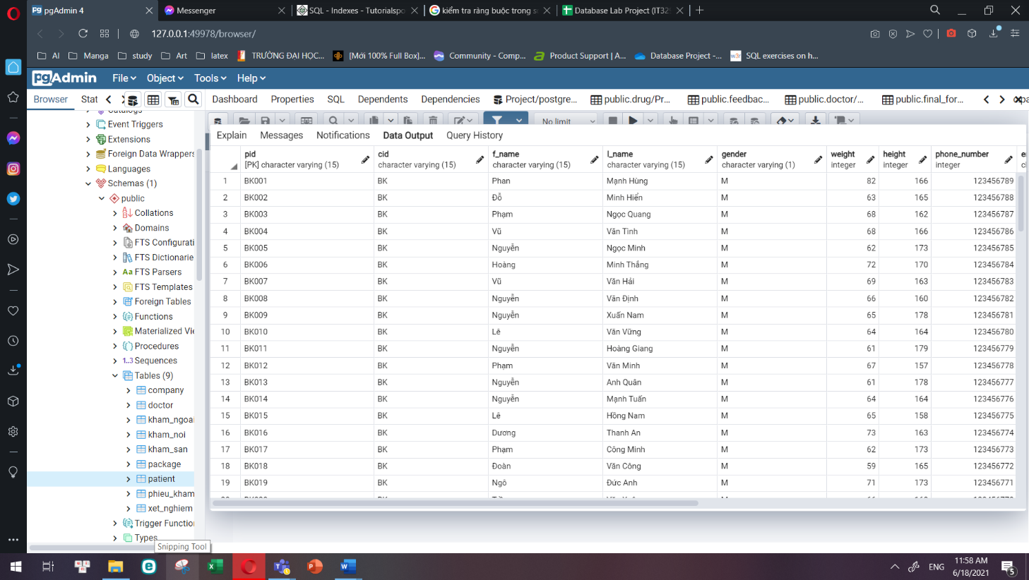

1. **Diagram**

* Model Diagram for Object:

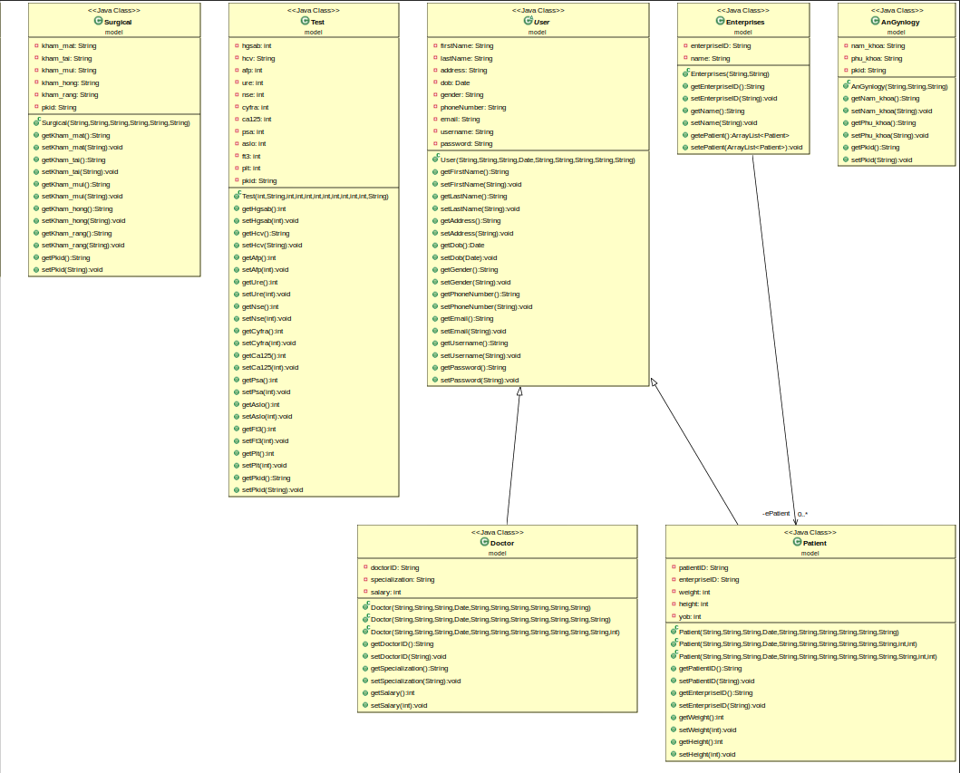

* And the Use Case Diagram of this program:

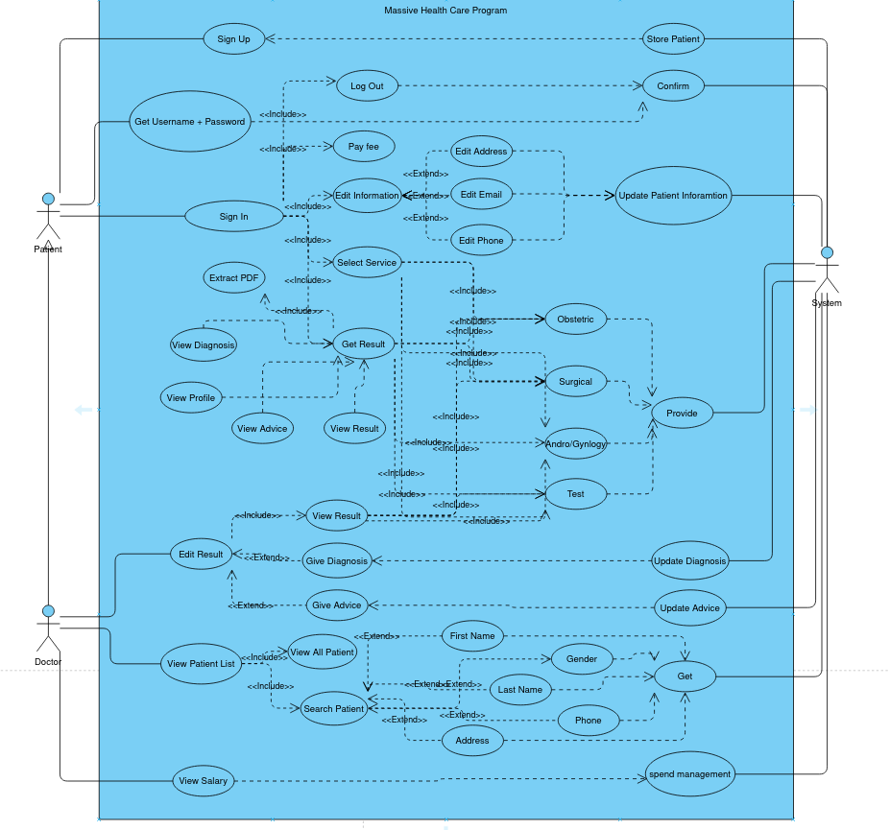

1. **Overall virtualization.**

* At first program running, user must input username and password. If user do not have an account, they can sign up by clicking “Sign up button” . If the user forgot username or password, they could look them up in the forgot button if they provide the system their correct id. After finish input username and password, system will check the database to determine whether the user is patient or doctor base on their id: *did* or *pid.* Then system will move to either the Doctor – view window or the Patient – view window.

1. Patient – view

The window includes a site to show patient information and a list of buttons. Patient will click on the button and the main window shifts to the next window. Patient’s buttons are: “Edit information”, “Choose service”, “View result”, “Log out”.

* Edit information: Patient can edit some information by changing in the Textbox then submit it.
* Choose service: Patient will choose the type of service they want to make an appointment, and then the date. Information about the service is shown nearby.
* View result: Patient can view the result and more information of their services in the past (like an history check).
* Log out: Log out to the Sign in window.

1. Doctor – view

The window includes a site to show doctor information and a list of buttons. Doctor will click on the button and the main window will shift to the next window for the doctor to work on. The buttons are: “View patient”, “Edit result”, “View salary”, “Log out”.

* View patient: This function works like a search tool. Doctor will enter filter information, then the system will query it in the database, and then show it to the GUI as a table of information.
* Edit result: Doctor will enter the *pid* then the window will shift to the edit window for the patient with the *pid* the doctor enters. Then doctor will edit the patient result of his/her appointment, give diagnosis, and advises.
* View salary: View doctor salary of the month.
* Log out: Log out to the Sign in window.